Performance Progression Analysis of Austin Reaves (2021–2025)
This document contains dataset, analysis, visualizations, regression summary, and predictions for Austin Reaves.

Dataset
Columns: Season, PPG, RPG, APG, MPG, FG%, 3P%, FT%
Season | SeasonIndex | PPG | RPG | APG | MPG | FG% | 3P% | FT%
2021-22 | 1 | 7.3 | 3.2 | 1.8 | 23.2 | 45.9 | 31.7 | 83.9
2022-23 | 2 | 13.0 | 3.0 | 3.4 | 28.8 | 52.9 | 39.8 | 86.4
2023-24 | 3 | 15.9 | 4.3 | 5.5 | 32.1 | 48.6 | 36.7 | 85.3
2024-25 | 4 | 20.2 | 4.5 | 5.8 | 34.9 | 46.0 | 37.7 | 87.7

Key Visualizations
PPG Trend:
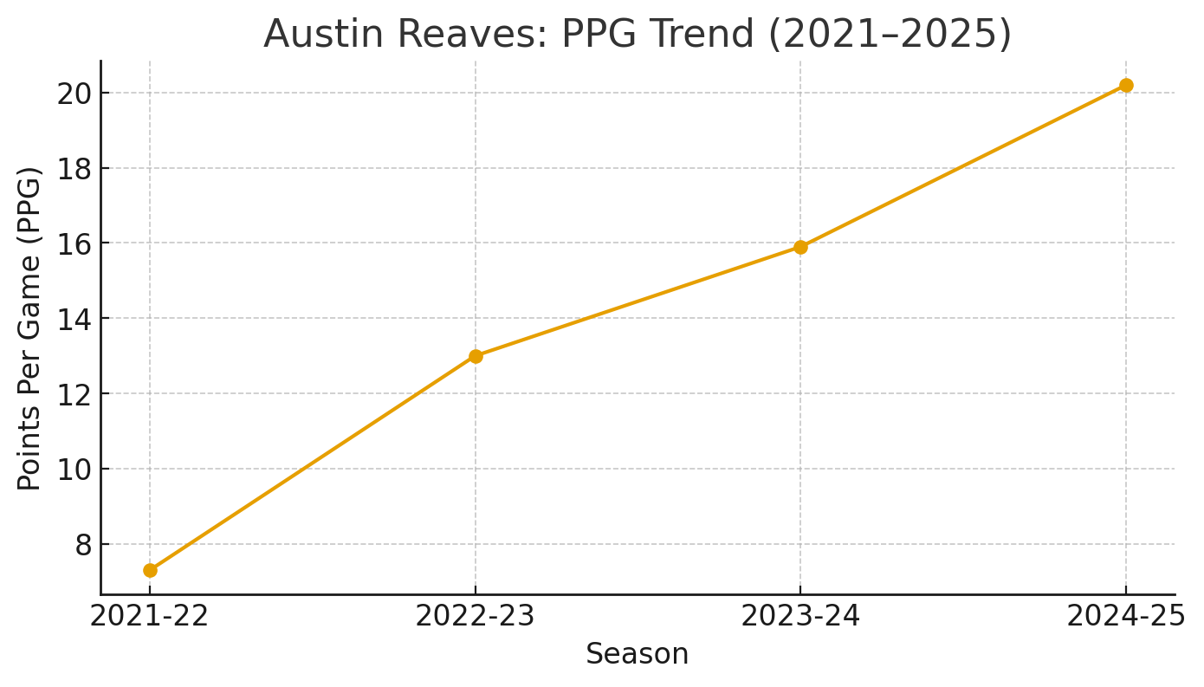
MPG vs PPG Scatter (with fit):
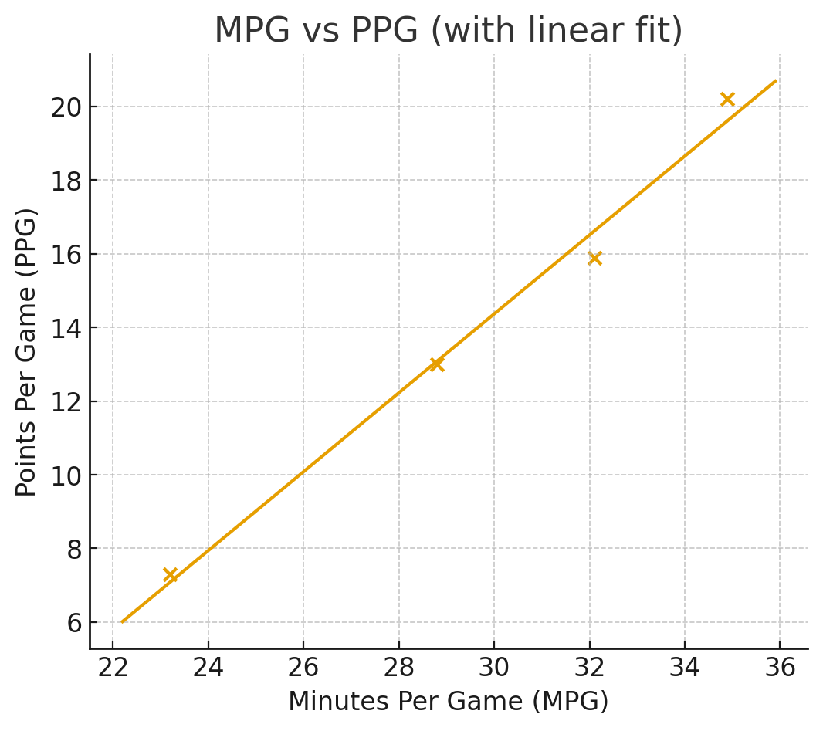
Correlation Heatmap:
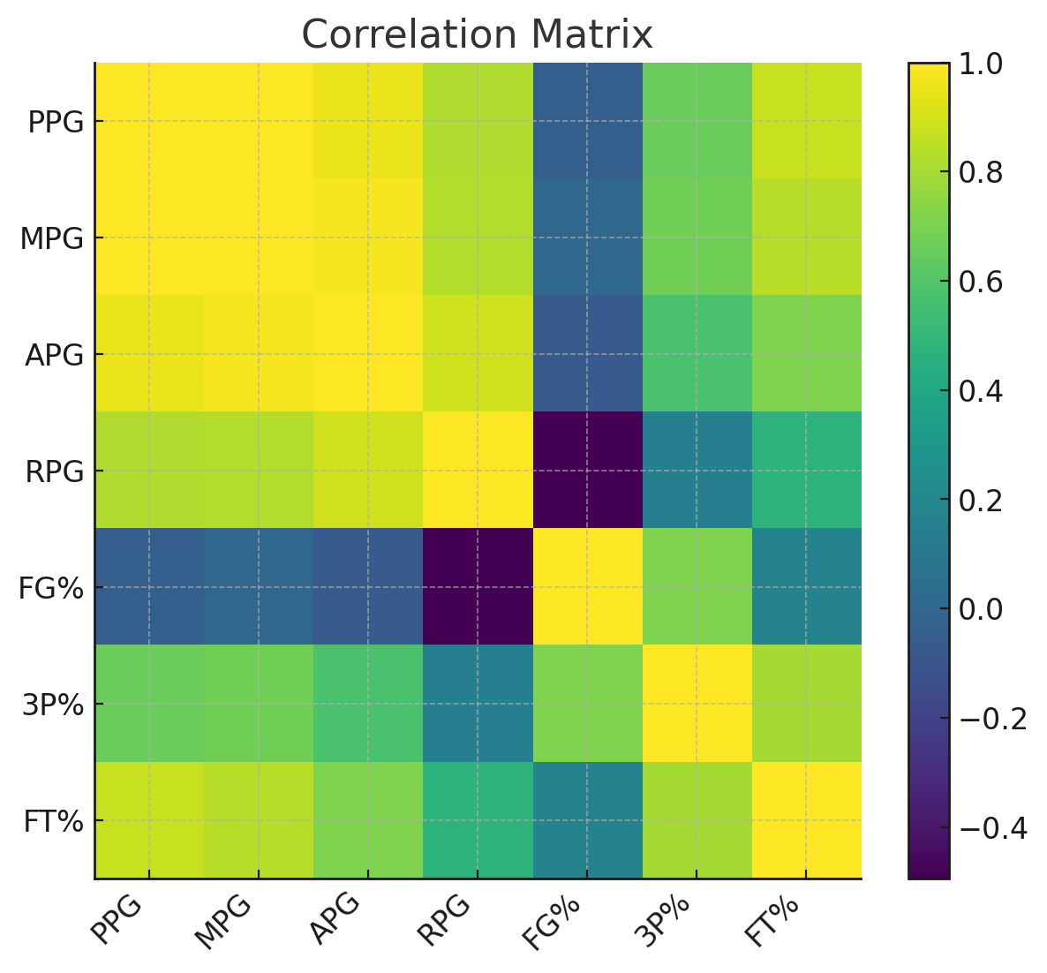

Regression Summary (PPG ~ MPG + APG)
The regression summary is saved as a text file in the project folder. Key takeaways:
- The model suggests that Minutes per Game (MPG) and Assists per Game (APG) both positively relate to PPG.
- With limited data points (4 seasons), statistical power is low; interpret results cautiously.

Predictions for 2025-26 (Simple season-trend linear model)
PPG: 24.5
MPG: 39.35
APG: 7.65
RPG: 5.05
FG%: 47.35
3P%: 40.2
FT%: 88.4

